Name: Pranali Sonawane
Subject: CCNA
Lab – Port Security using static Configuration:
First, we have taken one switch and two PCs. The PCs are connected to the switch using straight-through cables. The PCs are configured using static IP addresses.
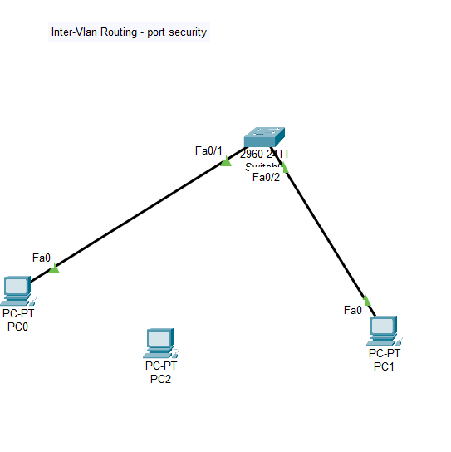
Switch (config)#interface fa0/1
Switch (config-if)#switchport
Switch (config-if)#switchport mode access
Switch (config-if)#switchport port-security
Switch (config-if)#switchport port-security mac-address sticky
Switch (config-if)#switchport port-security maximum 1
Switch (config-if)#switchport port-security violation shutdown
Switch (config-if)#do sh his
Switch (config-if)#exit
Switch (config)#exit
Switch#show port-security

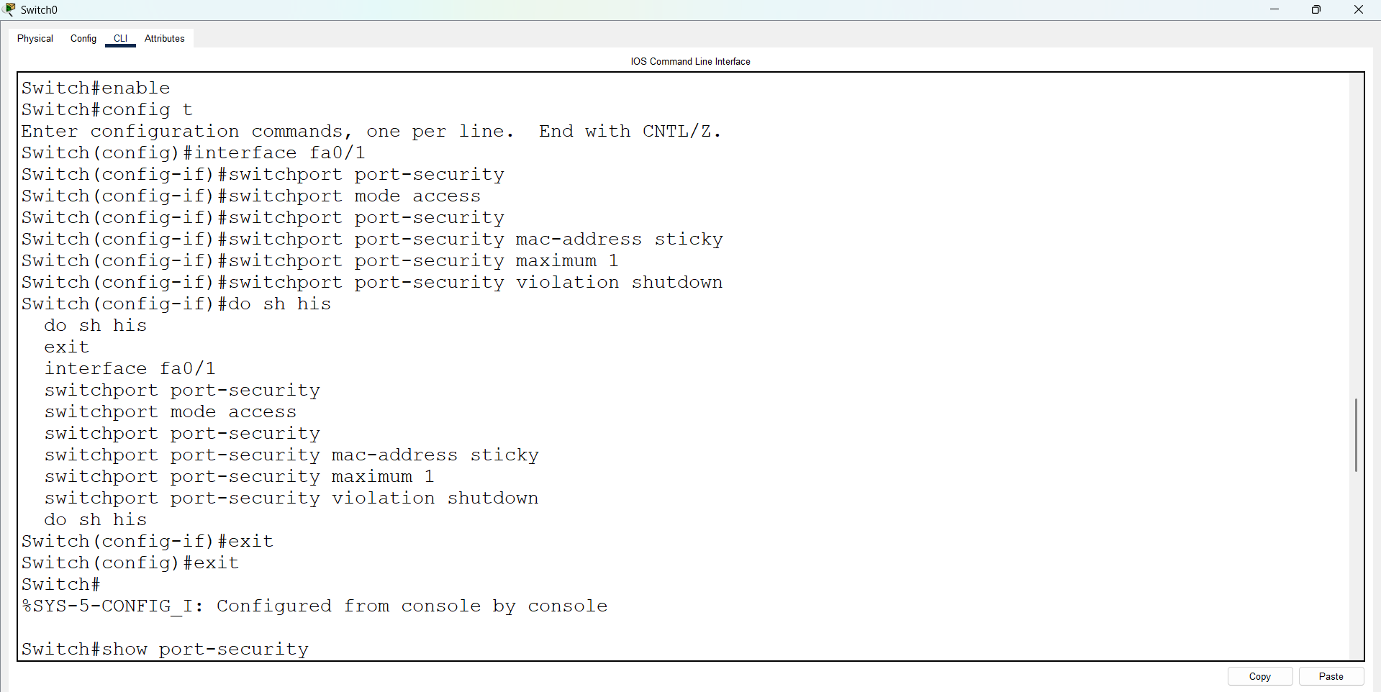

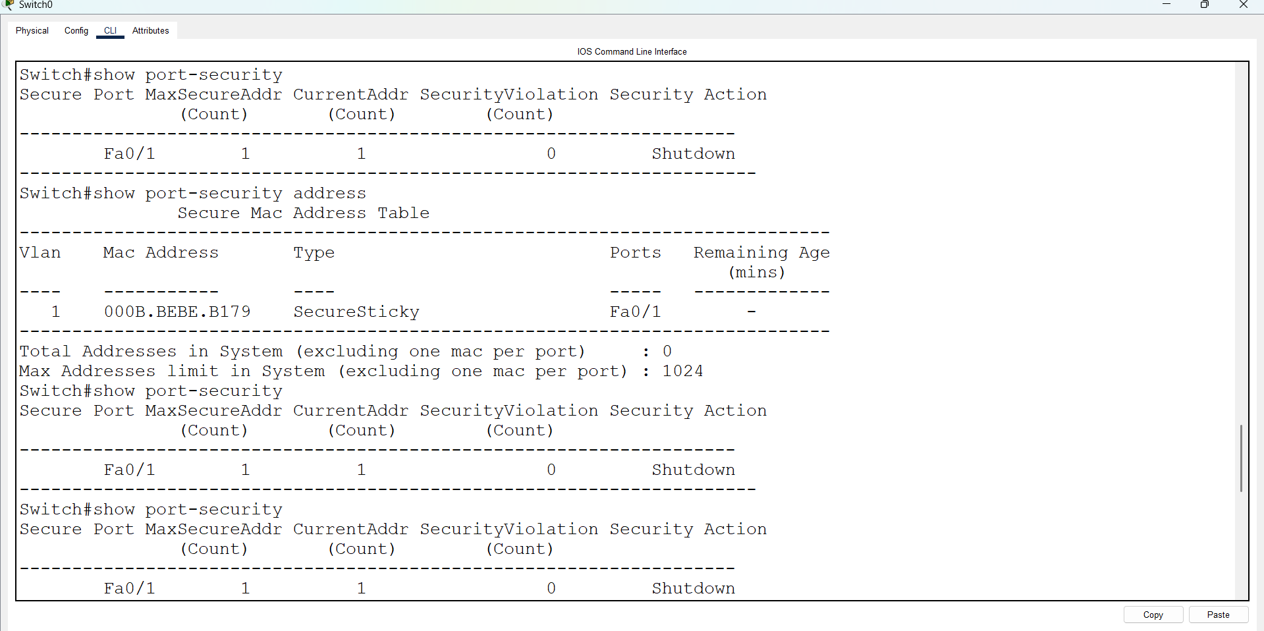
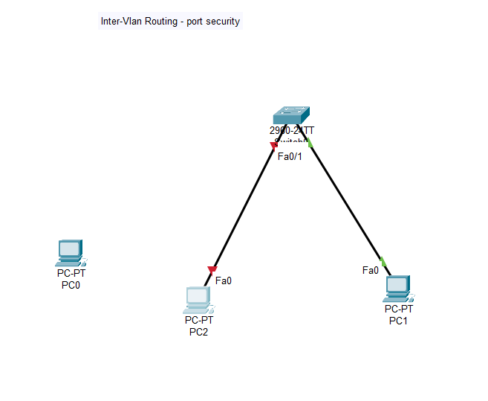
After pinging the PCs, the current address count is 1. In the diagram above, when PC0 is moved from port Fa0/1 to PC5, it shows a red color (indicating a connection issue). After reconnecting PC0, enter the following commands:
Switch> enable
Switch# configure terminal
Switch(config)# interface fa0/1
Switch(config-if)# shutdown
Switch(config-if)# no shutdown
